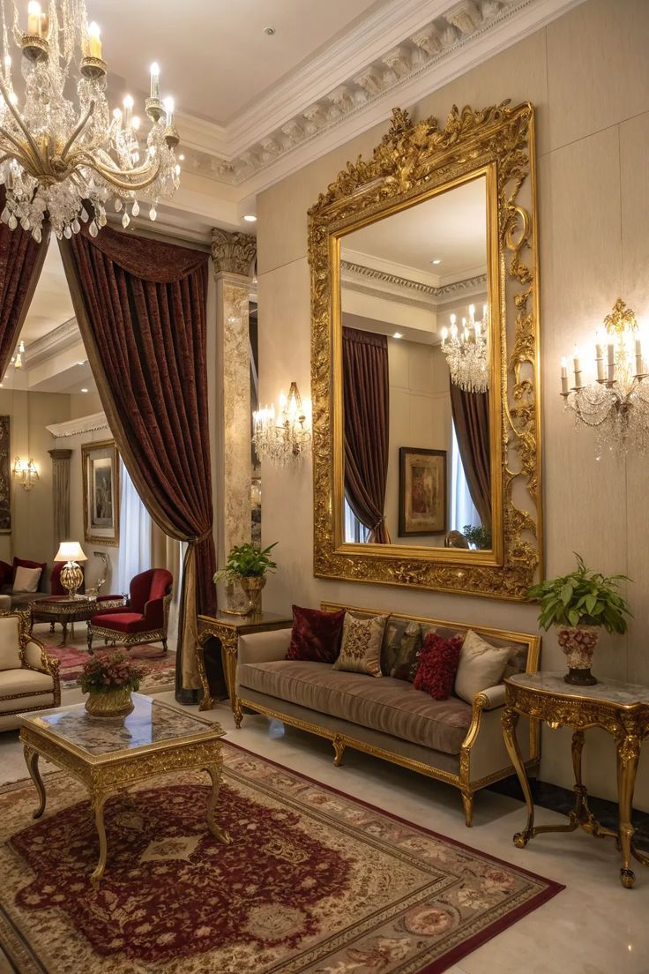***Elevate Your Living Room with Timeless Mirror Elegance***

Your living room is the heart of your home — a place where comfort meets style. Our collection of **Living Room Mirrors** is thoughtfully crafted to bring a perfect balance of function and sophistication to your interior. These mirrors not only reflect light, making your space appear brighter and more open, but also serve as stunning decorative elements that elevate the entire ambiance of your room.

Whether you’re going for a sleek modern look or a warm, rustic feel, our mirrors come in a variety of designs and finishes to match every taste. From elegant gold-framed masterpieces to minimalist frameless panels, each mirror is made with premium materials to ensure durability and visual 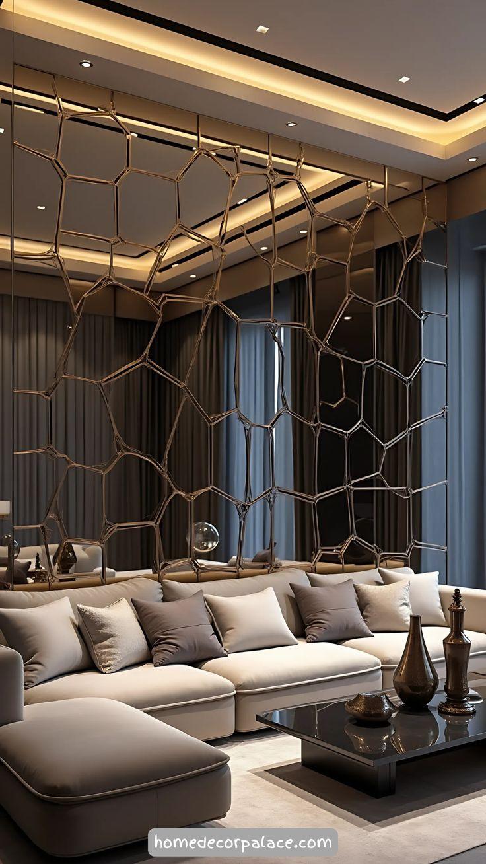appeal. Add depth to your walls, create an illusion of more space, and express your personal style with a piece that does more than just reflect.

Let your living room make a lasting impression — with a mirror that truly reflects your vision. From contemporary frameless designs to ornate vintage frames, every piece in our collection is carefully crafted to suit diverse tastes and living room themes. Whether mounted above a sofa, fireplace, or console table, our mirrors add visual interest and depth, making them the perfect finishing touch for any modern or traditional home.